**Portfolio**

**SIT162 - Introduction to Creative Technologies**

**Name: Owen Wang**

**ID: 217209562**

**Link:** <https://github.com/OwenWY/SIT162/tree/master>

**Portfolio element 1:**

Firstly, I use GitHub to manage files.

Through the week one, I have a preliminary concept of creative technology that combination of technology and art. For this technology, I need to know practically popular technology and design tools. For example, HTML, CSS and JavaScript on the Adobe Dreamweaver, especially HTML5 and CSS3 that promote the stronger function, design tools Photoshop and Adobe Premiere Pro. HTML5 is a Hypertext Markup Language that is a major part of the content displayed on the website. CSS is the style list that can adjust the style of HTML. JavaScript is lightweight programming language. It is mainly responsible for accessing database and doing special effects on front – end. So, the front – end development of web includes HTML, CSS, JavaScript and other frameworks. As an example VUE.js and Bootstrap. Currently, more and more HTML5 games and interactive products are growing. Because of HTML5 supports multiple platforms including Android, PC and IOS. H5 game based HTML, CSS and JavaScript development. In my group, I should know the recording video and design some elements. Because of my major was a design before. So I can do design for my group.

**Portfolio element 2:**

This week I learned to create and design posters or picture using Photoshop and I know some video skills that is Premiere Pro to and After Effects. Photoshop is a graphic production software. The Photoshop is piratically powerful. Because we can make posters, some elements for video and website design. It also makes animations. So, I make a poster using Photoshop.

***Making steps (Background image of character)***



**Background images of scenery**

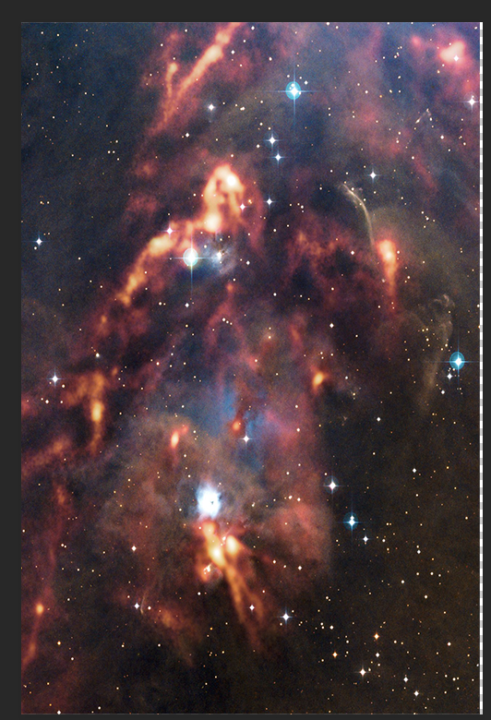

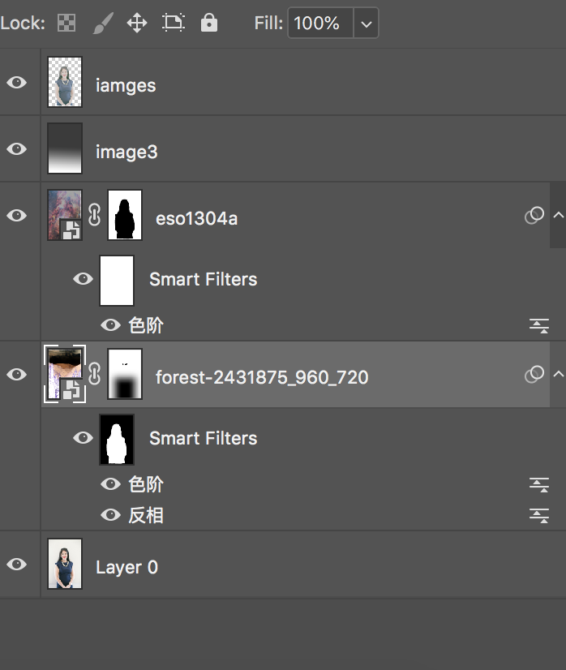

Reversed phase

color gradation

color gradation

***The final picture***

This effect mainly applies the mask effect and the layer overlay in PS, need to master the basic tools of Photoshop.

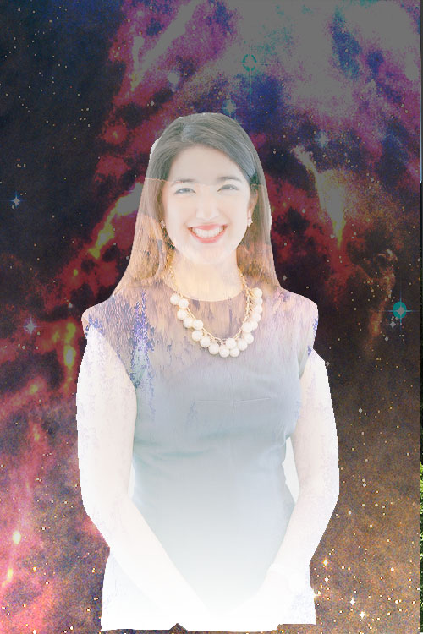

This week I have learnt Adobe After Effects. Then I made a flower open animation. The AE is especially interesting. Because of I can synthesize the screen and make an animation. Which contains the petals material. This skill can also help the team to make videos better.

***Timeline***

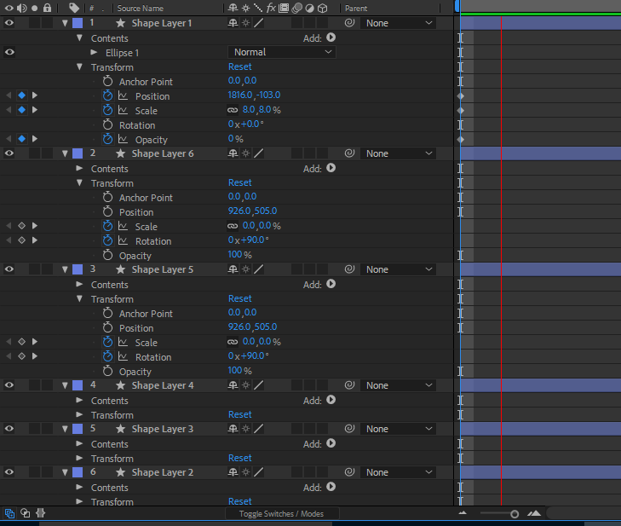

***Effects***

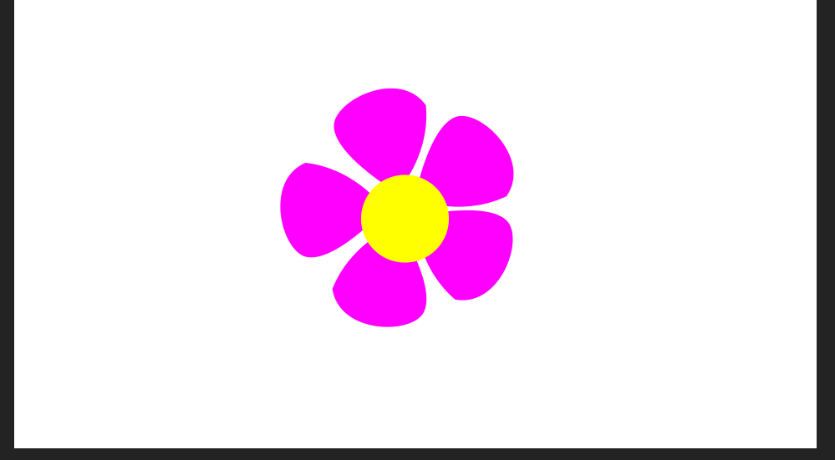

**Portfolio element 3:**

This week I have grasped HTML5 and CSS. The HTML 5 is a Hyperlink scripting language and CSS is Stylesheet. Css3 has powerful functions that many new style functions have been added. Especially CSS Animation. HTML5 adds a new semantic tag. The l understands some JavaScript that is lightweight language. Because of single data type. In particular, jQuery refresh the efficiency of JS and enhance the diversity of front-end pages.

First part: UI Effects. This is mainly focused on some style settings of HTML and CSS. Special application of pseudo class in CSS. Each button has different effects when the mouse focuses on UI. I used the label that is <div>, <h1>, <button>. The div is characterized by the definition of width height, vertical alignment, h1 is the title, and buttons are the component. CSS defines the properties of labels, such as location, size, color, and effect. In particular, :hover, :before and :after are pseudo classes of CSS.

***HTML5 Codes***

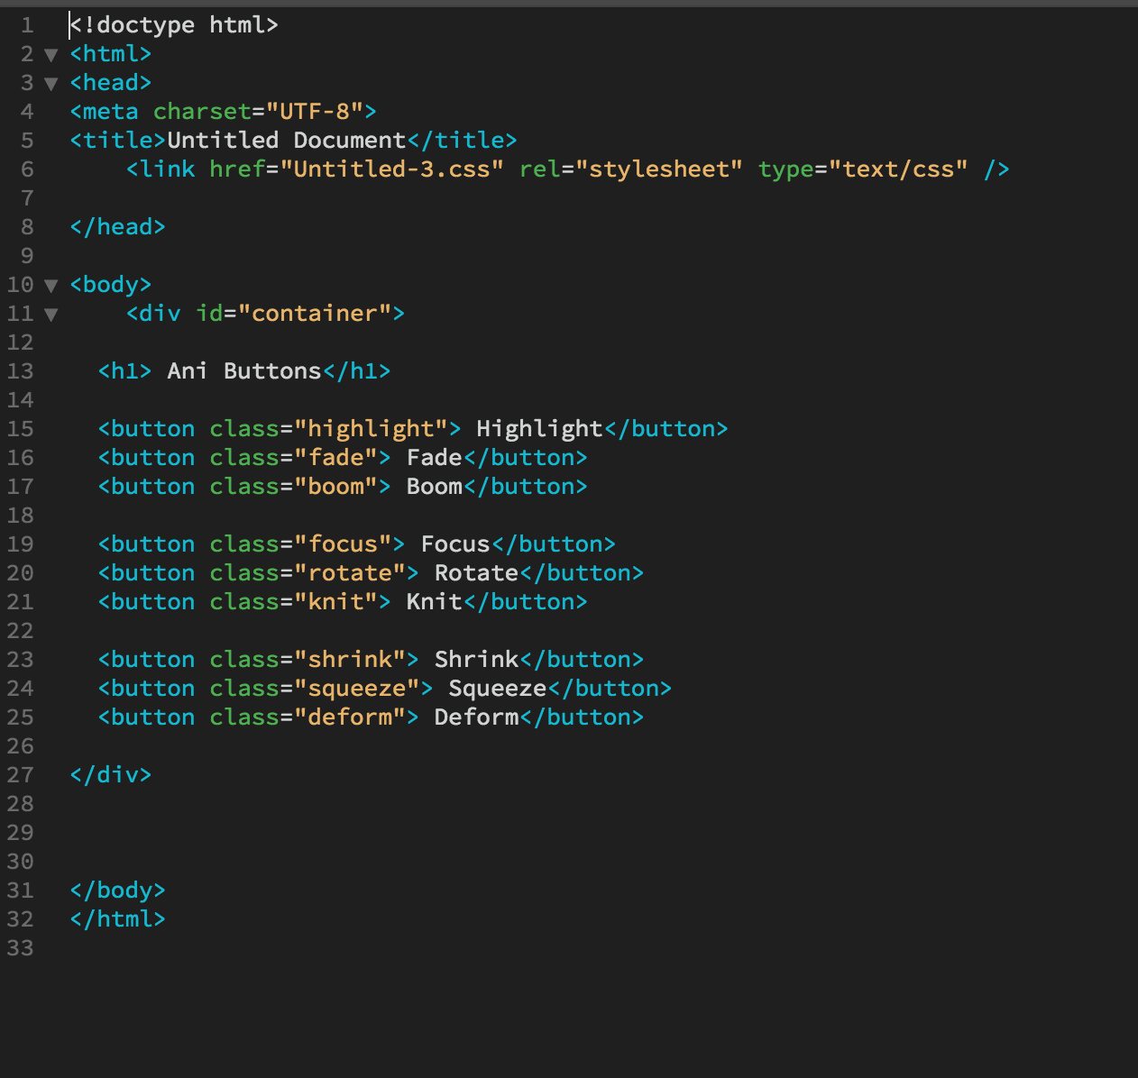

***CSS codes***

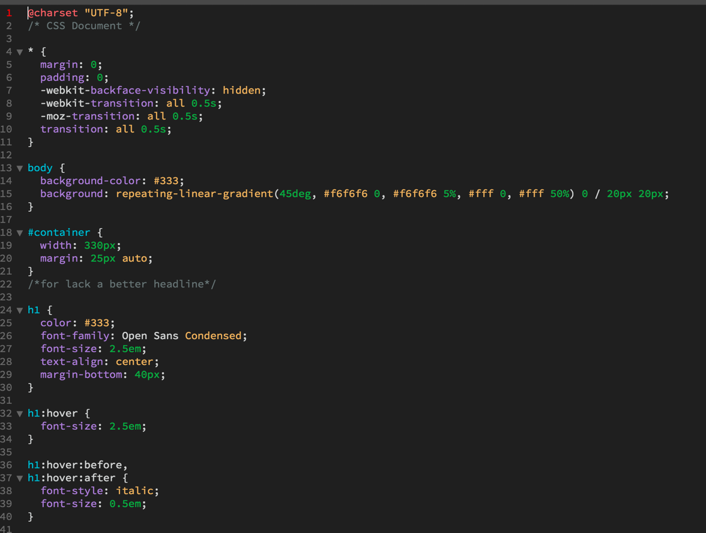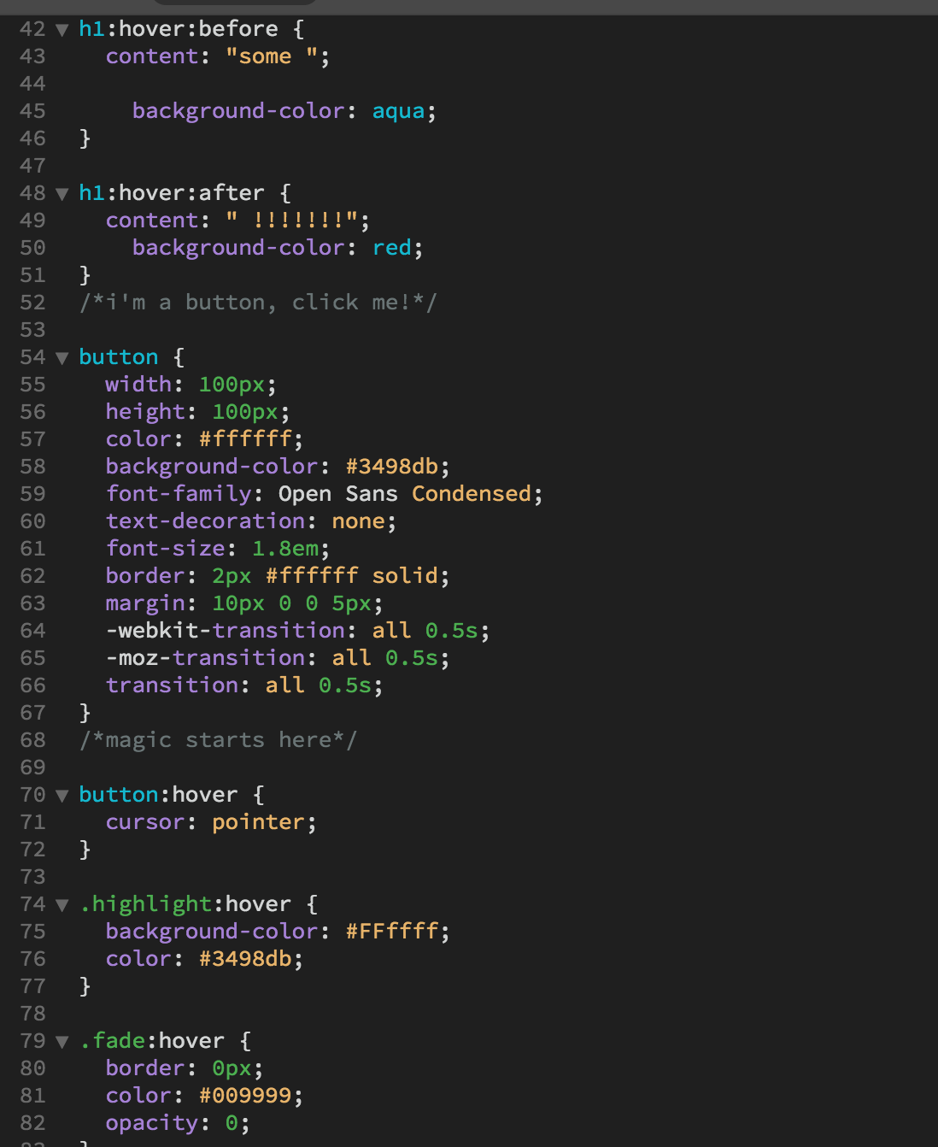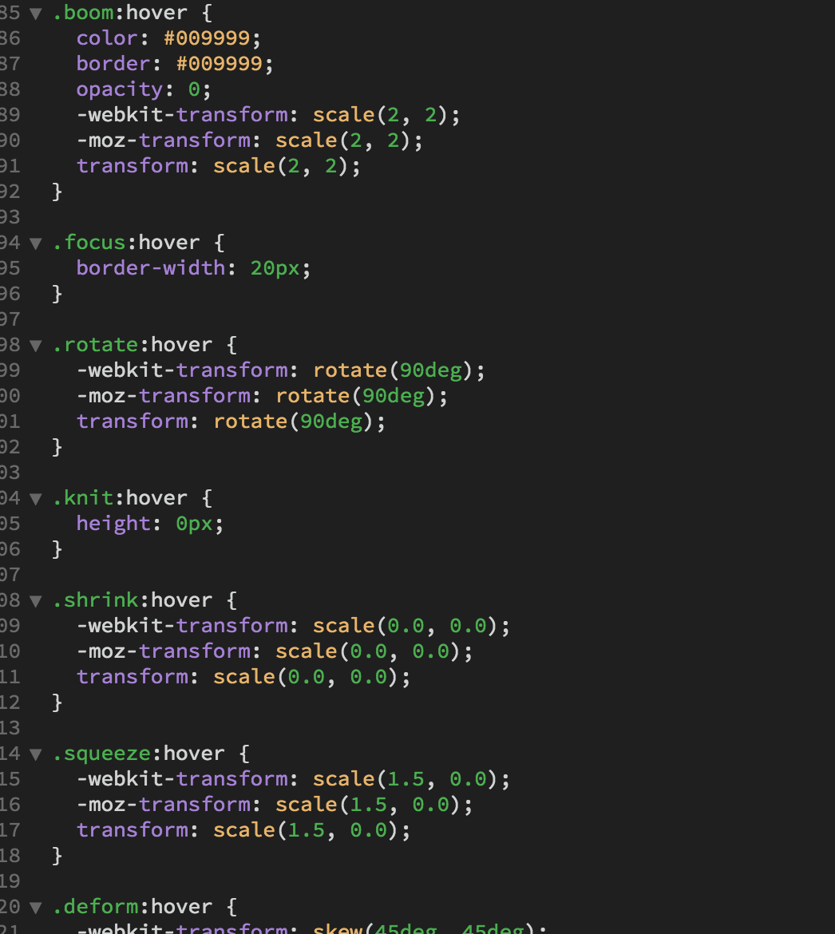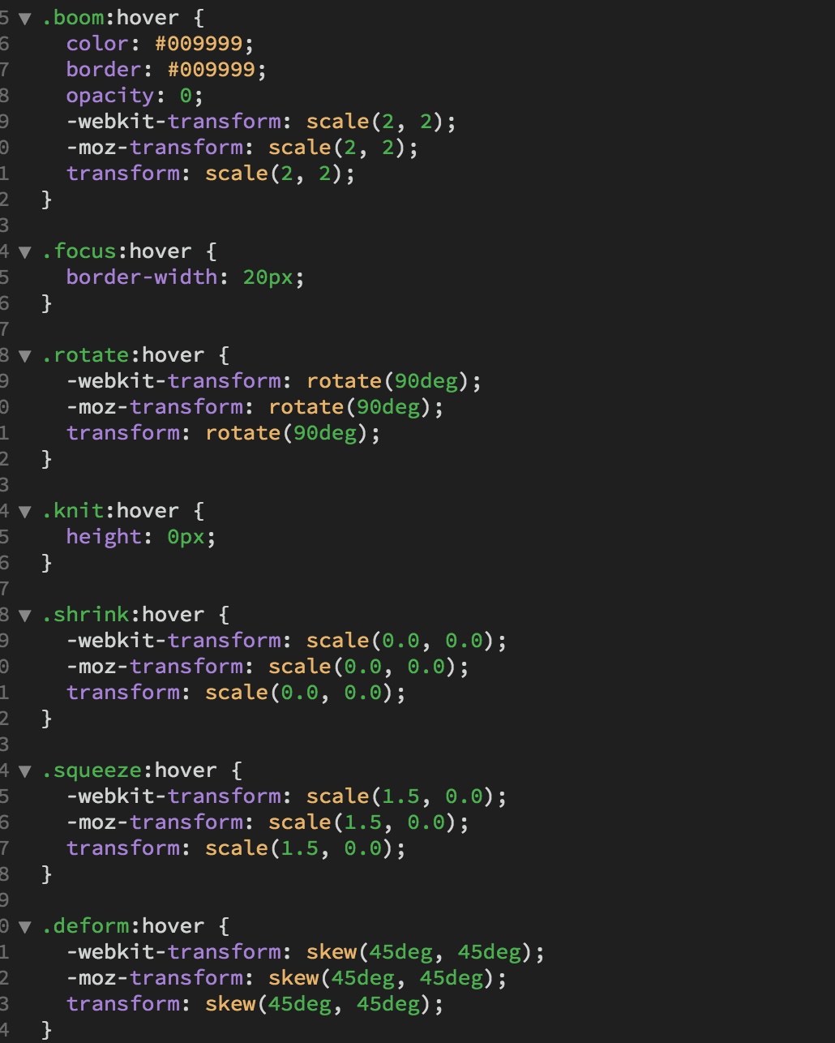

Pseudo classes

**Portfolio element 4:**

This week I have achieved CSS of final. I used CSS of animation function to do the UI animation effects. Therefore, each button has different effects. Through research, the CSS is faster than JavaScript, because of invokes hardware accelerate. The properties of the products can also define directly via CSS. Finally, I achieved and researched this web page. I have mastered the basic webpage knowledge.

***CSS Codes***

This is the animated attribute of CSS, which belongs to CSS3.

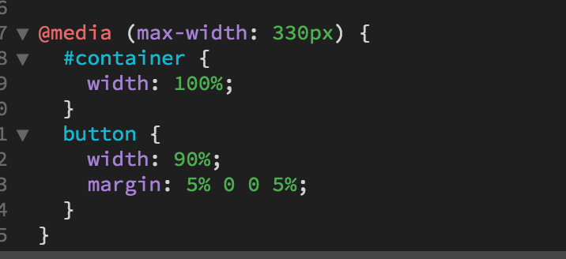

***Web Page (Animation and Effects)***

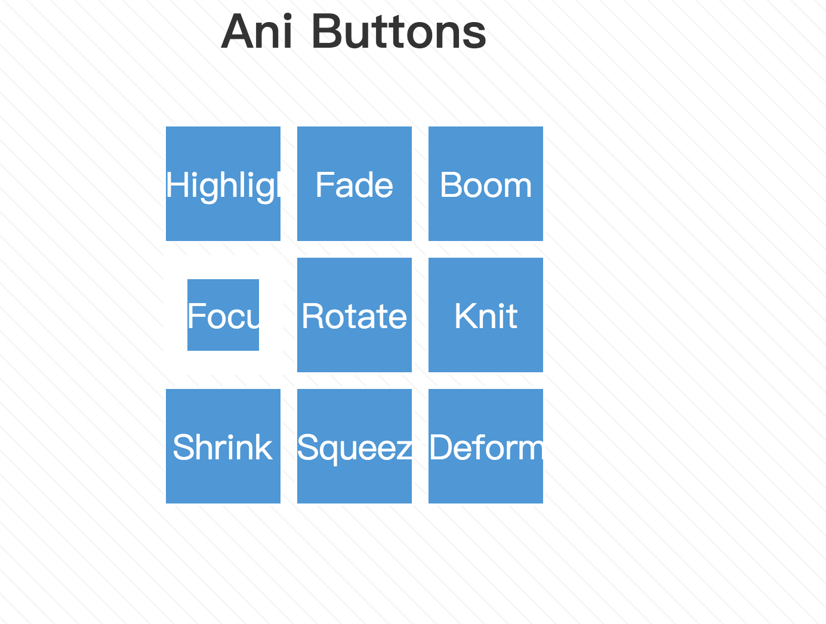

Second part: Effects

This is a website for text effects, implemented with HTML and JavaScript. The JavaScript introduces third party plug-ins that is jQuery.

HTML

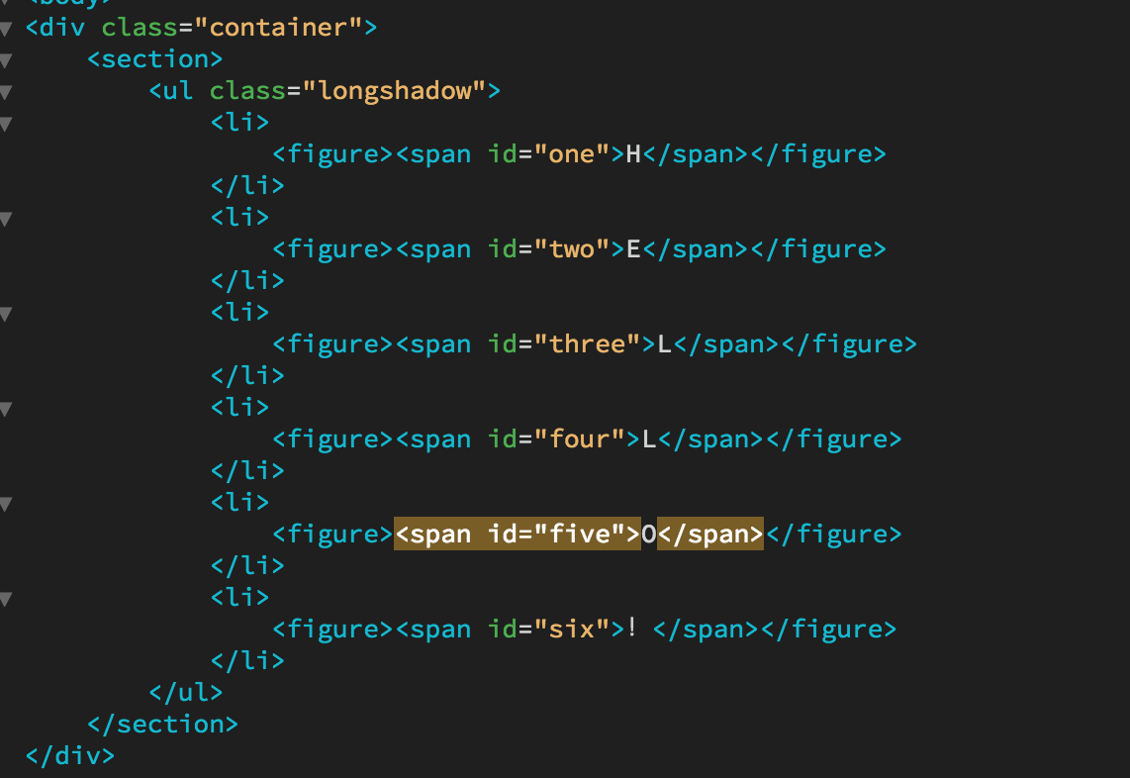

UL is unordered list. Li is a subset of UL.

JavaScript

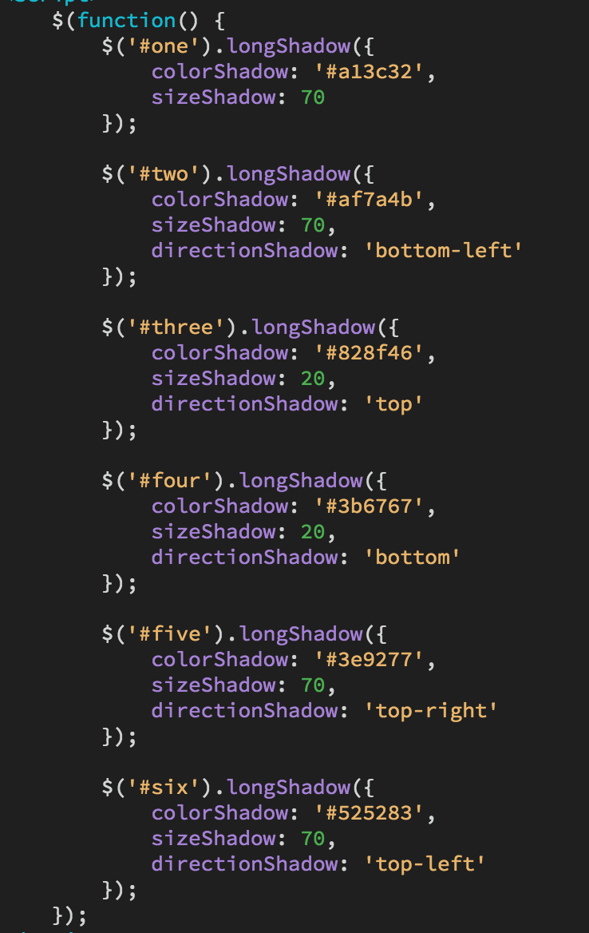

$ is a symbol of jQuery.

Get label contents and label properties

The final result



**Portfolio element 5:**

This week I learned about data analysis about face recognition technology. Face recognition is a special fire technology. For example, Apple Inc has been studying face recognition for mobile phones. First of all, I used a character picture who is Justin. Then upload to the online identification website, you can analyze the results. This website encapsulates a lot of data. So we can easily get results.

This is picture from Google.



This is result. We can see that this person is identified.

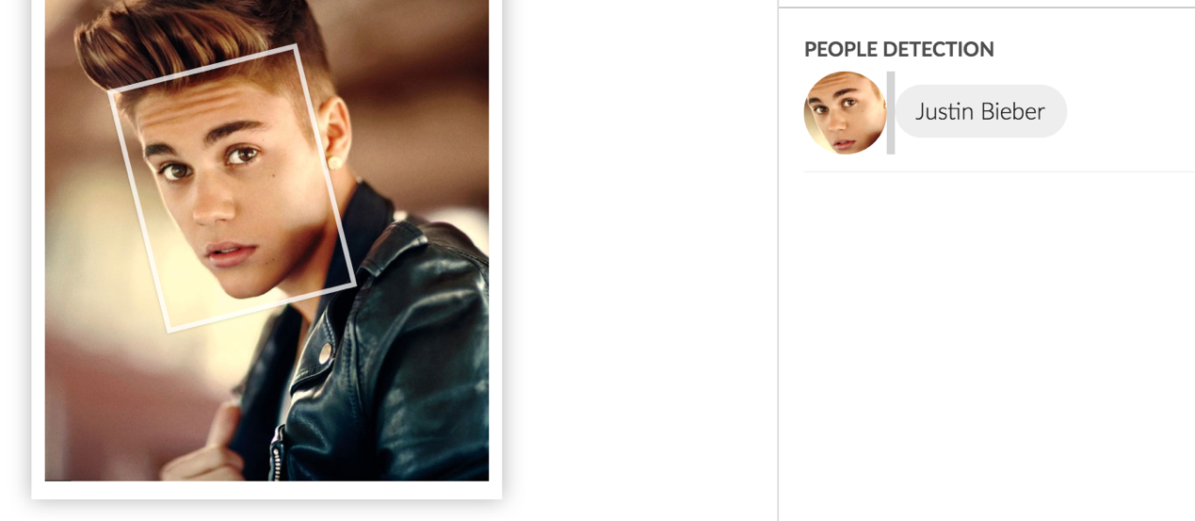

**Portfolio element 6:**

This week, this week, I learned about the use of game engines, such as Unity3D and UE4, But I focused on Unity3d, which is a particularly popular game engine, especially mobile games development and virtual reality, augmented reality. This week I focused on the basic operations of Unity, for example GUI systems, animation systems, and some basic components, as an example cameras, lights and models.

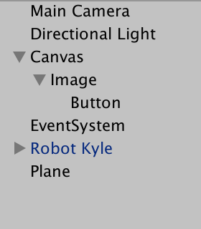

Landform

3d model

GUI System

light

Camera

This is GUI system and set position of UI.

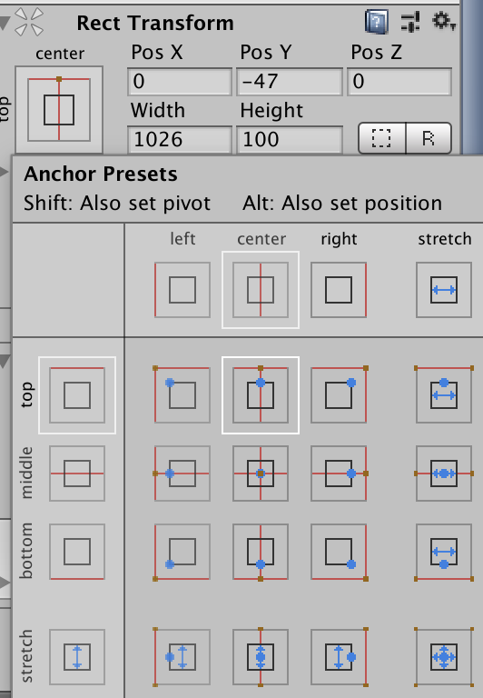

Effects on unity3D then publish it to the IOS platform. First, export the files in APK format. Then open and open the XCode and pour it into APK file, configure API to run.

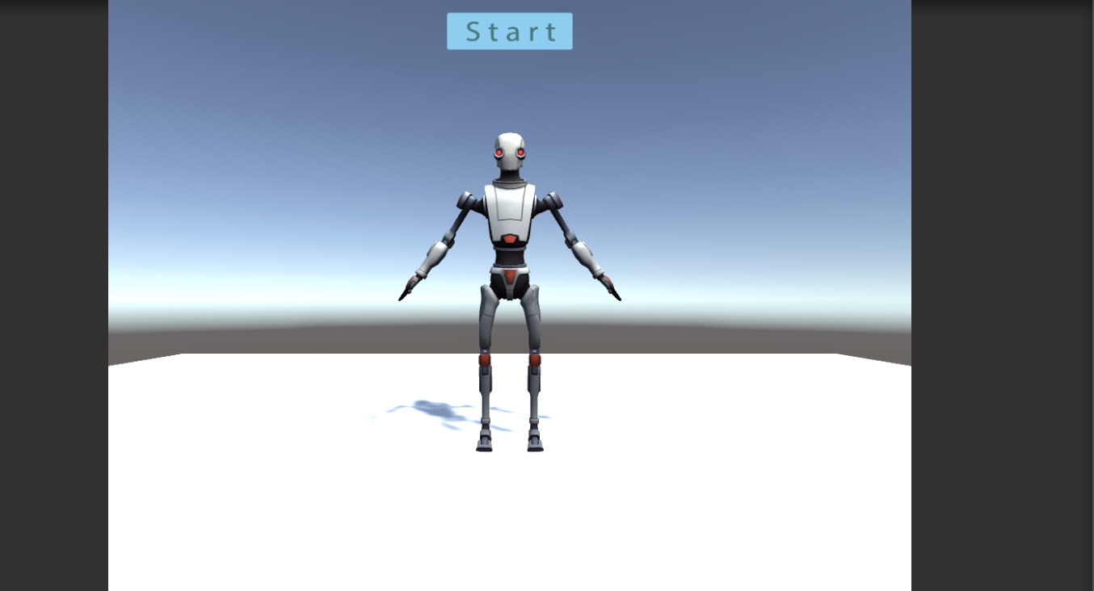

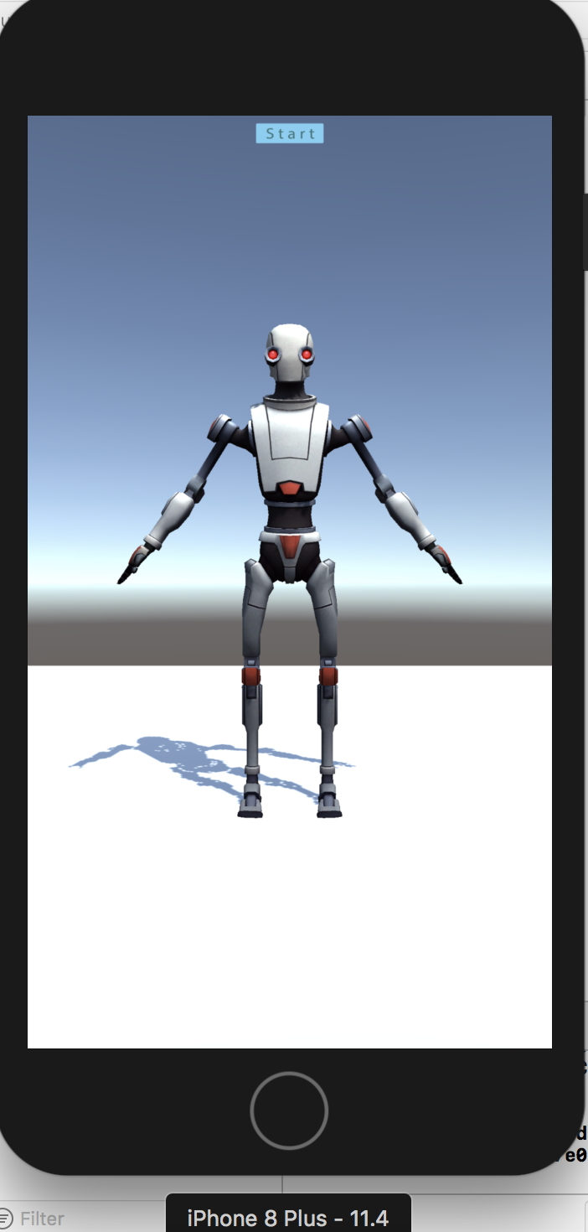

UI

**Portfolio element 7:**

This week I learned how to make a simple demo of AR. I used vuforia's SDK. Create an account, Download SDK, and create an identification diagram, import the identification map. Vuforia is a popular ar sdk. First, it's free. Second, it supports Android and IOS platforms. It's easy to use. Delete the main camera, then add the AR camera and ImageTarget.

This is project resources.

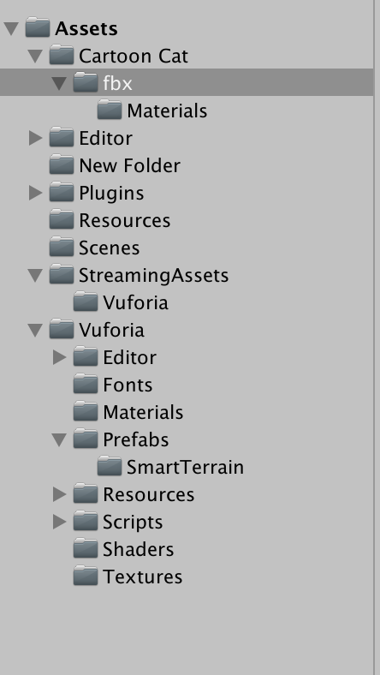

This is the resources already used.

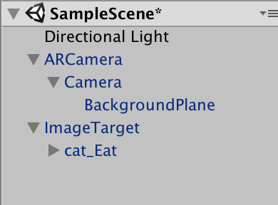

Identify Map



This is the most general picture, which can identify pictures.

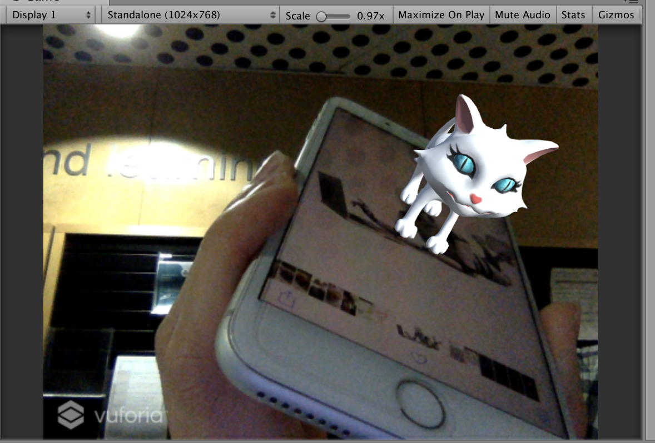

References:

Photoshop tutorials 2018, *How to Create a Mystic Lady Photo Manipulation*, retrieved 16 July 2018, <<https://www.photoshoptutorials.ws/photoshop-tutorials/photo-manipulation/create-mystic-lady-photo-manipulation/>>.

Adobe, *Create incredible motion graphics and visual effects*, retrieved 17 July 2018, <<https://helpx.adobe.com/after-effects/tutorials.html>>.

W3schools 2018, *HTML5 Tutorial*, retrieved 24 July 2018, <<https://www.w3schools.com/bootstrap/default.asp>>.

Kent C 2015, *Mobile Gyroscope with Javascript and Quaternions Programming Tutorial Part 1,* Asterixcreative, retrieved 01 August 2018,<<http://www.asterixcreative.com/blog/mobile-gyroscope-with-javascript-and-quaternions-programming-tutorial-part-1/>>.

Sightengine, *Detect and Recognize Celebrities in images,* retrieved 07 August 2018, <<https://sightengine.com/detect-recognize-celebrities>

Unity3d 2016, *Building your Unity game to an iOS device for testing*, retrieved 27 August 2018, <<https://unity3d.com/cn/learn/tutorials/topics/mobile-touch/building-your-unity-game-ios-device-testing>>.

Vuforia, *Getting Started with Vuforia Engine in Unity*, retrieved 03 September 2018, <<https://library.vuforia.com/articles/Training/getting-started-with-vuforia-in-unity.html>>.